SCAVENGER HUNT FUN FITNESS

* You may substitute other activities or movements in place the assigned activities for example do sit ups instead of push ups. And you can change the amount of the reps. You can create you own movement or activity or create something to find

1.Find something smaller

than your hand.

Bear Crawl for 3-5 seconds

2.Find something that feels bumpy.

Do 6 squats

3.Find something that starts with the same letter as your first name.

Do a 10 second run or march in place

4.Find something the same color as your eyes.

Do 6 toe touches

5.Find something larger than your head.

Do 5 star jumps

6.Find something lighter than a feather.

Do 4 push ups – may modify from knees or wall push ups

**Squats:**

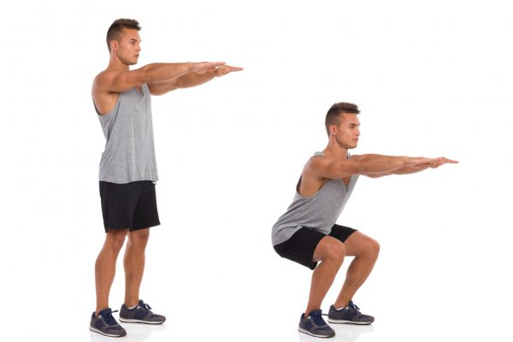

**Star Jacks:**

